Heather Vander Wilt

1. **Based on Boggarts: Fear into Laughter**

**6th grade**

**8 days**

**Big Idea**

**Transformation**

**Essential Questions**

Can fear be overcome?

Is it possible for fear to be transformed

into something lighthearted?

Why are we scared of the certain things?

**Key Concepts**

Overcoming fear

Bravery

Layering

**2.) Goal:** As a class we will talk about fear and overcoming fear. Students will write about one of their greatest fears in their journal. The project will be based on this idea of fear and overcoming it. Each student will make a linoleum print representing their fear, and then transform this into something that is ridiculous and lighthearted with collage techniques.

**3.a) Objectives:**

Students will discuss fear in large group and then journal about a personal fear. (NS 4, Critical Thinking, Complex Communication)

Students will create a representation of their fear with a linoleum printing techniques. (NS 1, 2, 3, Critical Thinking, Creativity)

Students will print 5 successful prints of their fear. (NS 1, 2, 3, Productivity and Accountability)

Students will transform at least 3 of these prints into something lighthearted, funny, or relaxed using a media that connects with their idea. (NS 1, 2, 3, 5, Critical Thinking, Creativity, Flexibility and Adaptability, Productivity and Accountability)

Students will choose their favorite piece to display and write about their work in their journal showing their understanding of transformation. (NS 5, Critical thinking, Complex Communication, Accountability and Productivity)

**4.)Prerequisites:**

Students should have basic knowledge of collage techniques.

**5.) Materials:**

Journal (paper), pencil, linoleum blocks, Steelball linoleum cutters, ink, scissors, magazines, tissue paper, paint, paintbrushes, colored pencil, sharpies

**6.) Safety Hazards:**

While cutting into the linoleum, we need to make sure both of our hands stay out of the carving tools way. The blades can easily slip so our fingers have to be out of harms way.

**7.) Interdisciplinary Connections:**

This lesson connects with language arts because students will journal about their experience with fear and how to transform it. They will describe if it is possible to overcome their fear.

**8.)Artist Resources :**

**Cindy Sherman**

*Cindy is a contemporary photographer, working today. She has a big idea of transformation. Sherman works in series, typically photographing herself in a range of costumes. To create her photographs, Sherman shoots alone in her studio, assuming multiple roles as author, director, make-up artist, hairstylist, wardrobe mistress—and, of course, model.*

Explain how Cindy’s use of transformation is the same or different from what we are doing for this project.

Do you think that it is important that Cindy is unrecognizable in each of each series?

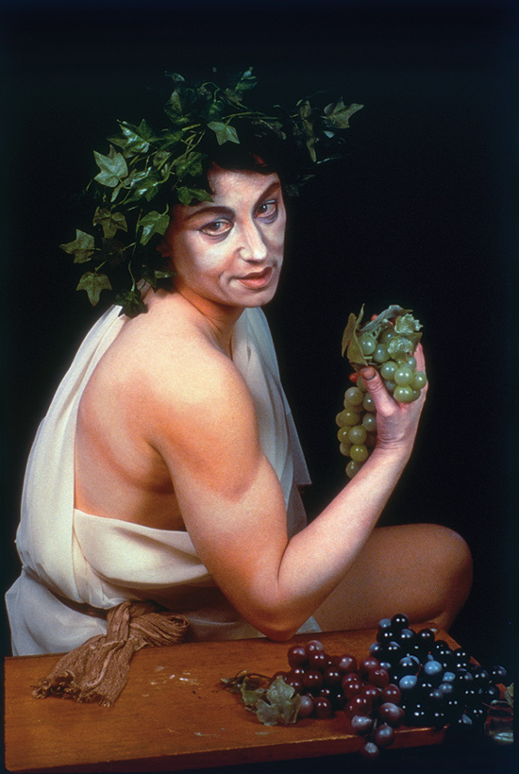  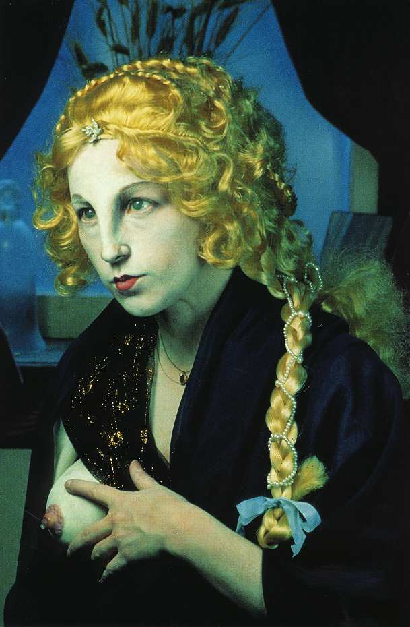

**Hannah Hoch**

*Hannah was a German Dada artist, so she worked during the beginning of the 20th century. She would collect images and then layer them to create something with an entirely new message. A lot of her work dealt with gender equality, because that was a really big social issue at the time.*

What message is Hannah giving off by creating a male profile with images of a female?

Explain how this artist uses transformation to capture viewers’ interest.

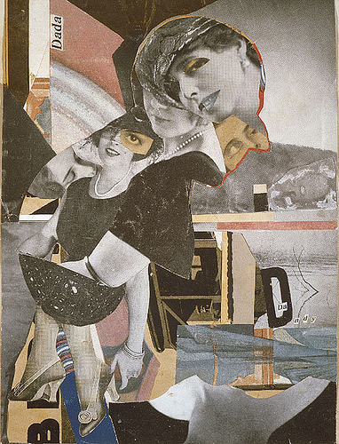 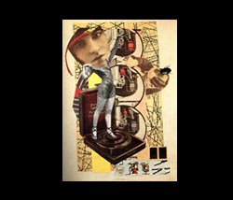 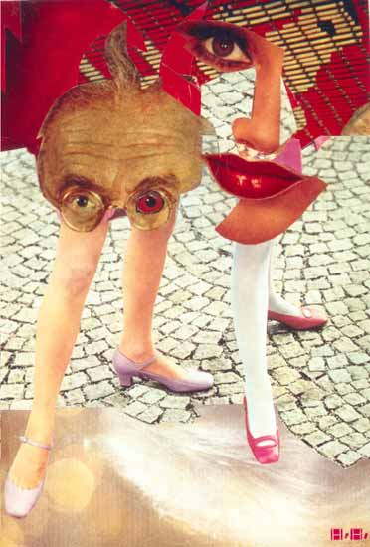

**Bill Fick**

*Bill Fick is a printmaker who lives and works in Chapel Hill, North Carolina. He is currently a Visiting Assistant Professor at Duke University in the Department of Art. He makes line drawings with ink and then translates this into a lino print. His work deals with monsters and gruesomeness.*

How can we relate this to our project?

What is a technique that he does in his prints that you can use in your own work?  
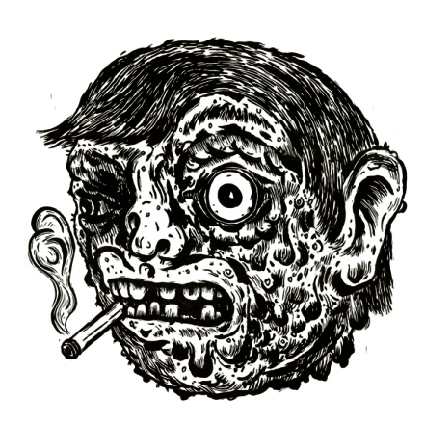 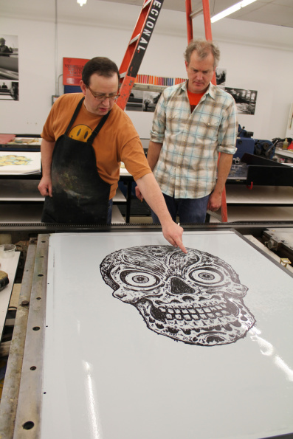 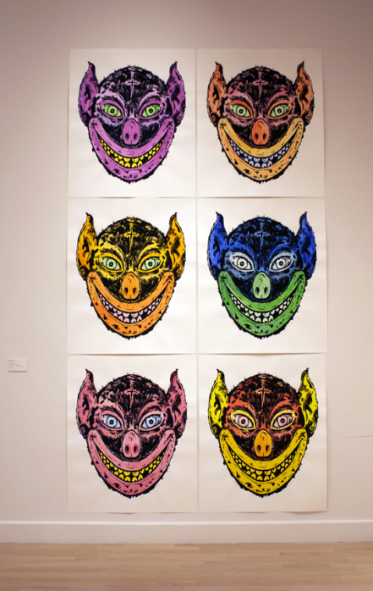

“Controlling the Monster” video found on http://billfick.com/

Harry Potter clip: In this scene the professor is showing the students a mythical creature called a Boggart that turns into the object that they most fear. To defeat this monster, one must think of someway to transform this fear into something silly. Laughter defeats the fear.

<http://www.youtube.com/watch?v=doxxfXqpKYA>

9**.) Lesson Procedure**

**Day 1**

**Introduction**

*Hello artists! It’s wonderful to see you again. Today we are going to start on our new project. In this project there will be two steps. First we are going to make a frightful print. Our next step will be to transform this fear into something lighthearted. This will happen in a series of days. Today we are going to discuss fear and come up with our idea. From there we will turn that into a print, carving into linoleum, a material like what many floors are made out of. With this we are really going to concentrate on getting 5 prints that are nearly the same. Three of these are then going to be transformed into something quite different from your fear. I’m going to show a clip of a Harry Potter.* *see above

*So lets talk about one of the examples that the clip gives. Ron’s biggest fear is spiders. If Ron was doing this project, he could draw a really creepy hairy spider. That’s the part that you are doing today. Then he would transfer this drawing onto the linoleum. Next he would carve this drawing into the linoleum, and use this like a stamp. Ron could then transform one of those spiders by making some roller skates to put on each creepy leg.*

**Work time**

*Right now I want each of you to get out your sketchbooks and make a list of fears that you have. Then circle the fear that you want to work with. For this fear, each of you will create at least three sketches of how you could draw this on your linoleum block. These drawings should all pretty different so you have options to choose from for your final print. By the end of the day, you should have your fear decided and the drawing of your fear.*

**Closure**

*Great job today students! You should have your idea chosen and ready for next class. Put a star by the sketch you are going to use for this project.*

**Day 2**

**Introduction and Demonstration**

*Hey students. Today we are going to start by talking about Bill Fick, a printmaker who is interested in monsters, which may be a subject that some of you have chosen.* *see above

*Let’s talk about the steps that Bill Fick goes through to make a block. What did he do first? Right, he first made an ink drawing of his face. He used ink to get interesting line quality, which means there are thin and think lines in a various places around the drawing. Next, this drawing was transferred to the linoleum. He then uses different carving tools to cut into the block.*

*Everyone please gather around this table so I can show you how to cut into the linoleum block. Here I have my example block with my fear drawn onto it. There are four different blades for the carving tools. To change the blade, all you have to do is unscrew the metal part here, and then replace it with another blade. Each blade has a different purpose. For example, the large U-gauge is for cutting away big sections. The large V is for cutting sections where you want more control. To get even more control, use the small V-gauge, and if you want a super straight edge use the straight blade. Use the carving tool in a level motion; your blade should never be lost within the block, or you might chip it. It does not take too much pressure to carve into this. Remember when you are carving, that eventually the lines you make now may show up during the printing process. Be aware of those lines, which are called chatter; you can use them to really help your work. In a few minutes I am going to dismiss you back to your tables. I want you to continue working on your sketch if you are not done, otherwise start drawing your fear onto your block. After this, you may go to the back table and get the carving tools. I want two good questions before we begin.*

**Work time**

*I want everyone to complete drawing their fear onto the block. If you start carving into the block today, that’s great, otherwise we will all start tomorrow.*

**Closure**

*Warn when there are five minutes of work time left. *For clean up today, I want you to make sure the carving tools are all placed back into the boxes with the blades inside the handle. Put your blocks on the back counter, and put all the scrapes in the garbage. When you are done cleaning your area, sit quietly back at your table and I will dismiss you.*

**Day 3 & 4**

**Introduction**

*Welcome back students. Today we are going to continue carving into the block.* *Review instructions from Day 2 demonstration.

**Work time**

*Students will continue and complete carving into their block by day 4.

**Closure**

*Warn when there are five minutes of work time left. *For clean up today, I want you to make sure the carving tools are all placed back into the boxes with the blades inside the handle. Put your blocks on the back counter, and put all the scrapes in the garbage. When you are done cleaning your area, sit quietly back at your table and I will dismiss you.*

**Day 5**

**Introduction and demonstration**

*Hello art students. Last class, we finished up carving into our blocks and today we are going to print. So, today, we start the exciting part of actually making the prints. Before we get started, I have a few words I want you to know, this roller right here is called a brayer. This will be like our paintbrush for this project. This piece of metal is called the ink tray. And here are our cans of ink. So brayer, ink tray, and ink. Lets go up to the demonstration table so I can explain how we are going to do this today.*

*First, you all are going to use this knife here to get the ink out of the can. We do not want to put our knife too far into the jar, just skim the surface to get ink. I am now putting about a quarter size amount on the ink tray. Everyone see that? After this, I am going to use the roller to back and forth on the ink tray, until the ink looks like the texture of frog skin. Everyone take a look at this texture. Now, we are going to use the brayer on our block. Get a nice even coat, and load up on the ink tray again if you need to. You shouldn’t see any lines across the block from the ink or brayer. From here, carefully pick up the block and put it ink down on the paper in the center. Then press down the block with the palm of your hand. Make sure you don’t forget the edges or the corners. Next we are going to gently lift the paper from the ink tray, and carry the paper to the drying rack. So the steps are: get quarter size of ink, put it on the ink tray, roll in with the brayer until you see the frog skin everywhere, roll out the foam, and then print and rub the paper. Who can give me a good question about anything in that process?*

**Work time**

*Our mission today is for everyone to get one print done, you will have the whole time next class to print.*

**Closure**

Warn students when there is five minutes left until clean up. *For clean up today, I want the A person at every table to wash the brayers. The B person will wash the ink trays. The C person will use a rag on the tables and tidy everything up. All prints and blocks will go on the drying rack.*

**Day 6**

**Introduction**

*It is wonderful to see you again today students. Please take a seat quietly so we can talk about our goal for today. Yesterday, we all printed at least one print. Today the goal is to print four more prints. If you complete those four prints you may continue making more prints. Who can remind the class of the printing steps? Right Emily, we are going to get a quarter size of ink, put it on the ink tray, roll in with the brayer until you see the frog skin everywhere, roll out the foam, and then print and rub the paper. Who can give me a good question about anything in that process?*

**Work time**

Students will complete four prints during the class time.

**Closing**

Warn students when there is five minutes left of work time. *For clean up today, I want the A person at every table to wash the brayers. The B person will wash the ink trays. The C person will use a rag on the tables and tidy everything up. All prints and blocks will go on the drying rack. When you are done with your task, come up here and I will give you a sticky note and someone’s dry print from last week. I want everyone to leave one positive comment and one thoughtful question for this person and stick it on the back of the print. Both that student and I will be reading these comments, so make sure they use good artist language. Who has a question about clean up or the commenting on your classmate’s work?*

**Day 7**

**Introduction**

*Welcome back students. Last class we finished up our printing and today we are going on to the next step in the project. Who can tell me what transformation means? Great, transformation is the change in form or appearance. We are going to take our fears and overcome them by transforming them into something lighthearted. Remember the fear of spiders being transformed by adding roller skates to each leg? Each of you will do a transformation like this with three of your prints. Because I limited all of you had the same medium to work in for the first half of the project, there are tons of options for the transformation of your fears. I have ink, scissors, magazines, tissue paper, paint, paintbrushes, colored pencils, and sharpies for us to use. Are there any questions about the materials or how to use them? Great, well before we begin, lets look at two artists who use transformation in their work.* *see above Cindy Sherman and Hannah Hoch. *Cindy is essentially repainting her face to transform herself into something else. We can use a similar technique. You could simply paint over your print with acrylic or watercolor. If you add some of this glaze into your acrylic paint, it makes the paint more clear so you may be able to see through to your print. Hannah Hoch uses magazine images and construction paper cut outs in her work. Be really thoughtful in the images that you choose for this project. You all are, of course, able to use all of our materials. Be creative!*

**Work time**

*Students will have the whole class time to experiment with materials to transform their fears.

**Closure**

*Great work today students. For clean up, put all the scraps in the garbage. If you used anything that needs to dry, please put your projects on the drying rack. When you are done cleaning, I will dismiss you by tables.*

**Day 8**

**Introduction**

*Welcome students, last class we worked on transforming our fears into something silly by collaging. Today we are going to continue this. Who came up with a really cool collaging technique yesterday that they want to share with the class? ..That does sound like something many of you could try. Are there any questions about materials or what we are doing today before we begin?*

**Work time**

*Our mission today is to finish each of our transformations. You should have all three done by the end of class.*

**Closure**

*Warn when there are 15 minutes left of class. *Great work today students. For clean up, put all the scraps in the garbage. If you used anything that needs to dry, please put your projects on the drying rack. When you are done cleaning, please choose your favorite collage piece and one of your prints without collage. Put them on your desk because we are going to do a quick gallery walk just so you can appreciate all the hard work everyone put into their clever ideas. After we are done walking, please go back to your table and answer the questions on the board in your sketchbook.* *see assessment

**12.) Assessment**

Sketchbook questions:

1. How did you decide which fear to choose? Is it something that many people are scared of, or more personal?

2. Explain how you transformed your fear into something lighthearted, funny, or relaxed?

Project: Based on Boggarts: Transformation of Fear

Name:

|  |  |  |  |
| --- | --- | --- | --- |
|  | *1* | *2* | *3* |
| Fear Journal Entry and participation | *No journal entry / discussion* | *Poorly thought out* | *Well thought out* |
| Fear Print | *Unsafe, incomplete* | *Average completion* | *Excellent print* |
| Number of prints | *0-2* | *3-4* | *5* |
| Transformation of prints | *0-1* | *2* | *3* |
| Understanding of transformation | Shows no understanding | Average understanding | Excellent understanding |

Total score:

Additional Comments: