* **Elementary Art Methods Lesson Plan Template**
* **Hot Cocoa Mugs /3rd Grade /4 day lesson**
* **2.) Goals:**
* Students will be introduced to slab mugs, after reading the book “Hats, Gloves, and Hot Cocoa with Love”. We will repeat knowledge about patterns to create interest on the mugs. Students will use both relief and slip and score to create their patterns.
* **3.a) Objectives:**
* Students will read the book “Hats, Gloves, and Hot Cocoa with Love”, and reflect on their traditions during the winter months. (NS 4, NS 6, Critical Thinking)
* Students will experiment with different patterns on paper. (NS 1, NS 2, NS 3, Creativity)
* Students will create a mug that uses both relief and score and slip techniques to create patterns. (NS 1, NS 2, NS 3, Creativity)
* Students will make a three-piece mug: bottom, sides, and handle. (NS 1, NS 2, NS 5, Productivity and Accountability)
* Students will reflect on their project with hot chocolate reflection on the board. (NS 5, Critical Thinking, Collaboration, Productivity and Accountability, Complex Communication)
* **4.)Prerequisites:**
* Some knowledge of pattern making
* How to use a rolling pin, simple glazing
* **5.) Materials:**
* Paper, pencils, clay, needle tool, rolling pin, wooden tool, water/slip container, glaze, pop cans, paper towels
* **6.) Safety Hazards:**
* Students will be reminded to take care when working with water so they don’t slip. Students will be reminded that needle tools are only used in clay.
* **7.) Interdisciplinary Connections:**
* Math- repetition of design (pattern)
* Language Arts- Reading “Hats, Gloves, and Hot Cocoa with Love”.
* **8.)/Artist / Resources :**
* Talavera Mexican Pottery
* Talavera pottery is a special type of pottery that was made in Puebla, Mexico. It could only be made there because there was a special type of clay in the ground that wasn’t in other areas. It started to become famous about three hundred years ago when people really started traveling the world and trading things. People really loved how special the Talavera pottery looked. There were even certain people who tried to copy the style and sell it for less money. The people who made Talavera pottery were not too happy about this so they made special rules that someone had to follow. This way, it was less likely that people could make copies. The reason why we are studying this type of pottery is because of the pattern use. – Say to children day 1*
* 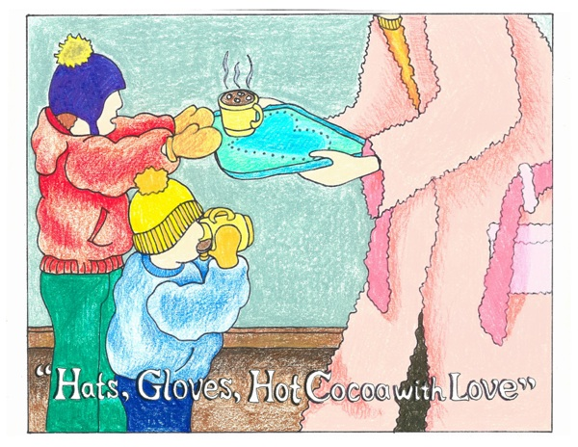
* Book by Gretchen Archambault
* 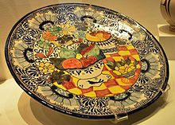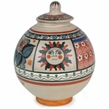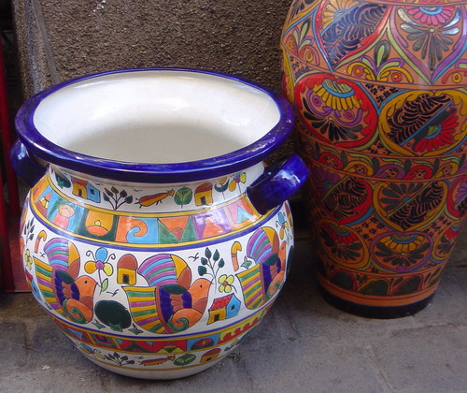
* 9**.) Lesson Procedure**
* **Day 1**
* **Introduction: 25 minutes**
* “Hello boys and girls, it’s so nice to see your lovely faces again this week. Today we are going to read a story, explain the next lesson, and do some practice and planning. Please sit on the carpet so we can read our book. Before we start, lets talk about some of the traditions you have during winter. For example, my birthday is during the winter so we always have lasagna, which is my favorite food. Who can raise their hand and tell me what one of their winter traditions is? … Great! Those are all excellent examples. That is what our book talks about. Since it is so cold outside, the main characters have a family tradition of making hot chocolate. As we read the story, make sure to look at the illustrations because there is an angel hiding on each page. *Read “Hats, Gloves, Hot Cocoa with Love”. * Now this is book is an excellent tie in to our next project. The main characters love hot chocolate right? Hmm... what could we make to hold hot chocolate in art class? That’s right! Mugs! *Show examples of mugs I own *

There are many different designs of mugs. Some are big, some small, some are one color, and some have many colors. We are going to make mugs with patterns on them. Now we have learned about patterns before. Who can remind me what a pattern is? Right! You learned about them in math class too, a pattern in art is when a design repeats. So it could be something like this. (Draw in board). Square, circle, square, circle. Or like this snowman, red dot, snowman, blue dot, snowman, red dot, what comes next? – Correct- blue dot! There is a special group of artists who use many beautiful patterns in their pottery. *Talavera artists (see above statement). Who has a question about patterns?

Remember those winter traditions that we brainstormed about before? On your mugs I want you to represent at least one of your traditions in a pattern, like I just did for my snowman. I want you to be as creative as you can. After I dismiss you from the rug, we are going to practice our mug design on a piece of paper. First we will fold the paper in half the hot dog way to make a crease. Then you can start your design. Do you see how I can make a cylinder shape out of the paper? You will just pretend that your mug is all rolled out while you are drawing. I want everyone to come up with four different mug designs. You have four different sections of your paper, two on the front separated by the fold and two on the back. I know we all think our first idea is our best, and even if you are super sure you are going to do your first pattern design, don’t raise your hand and tell me you are done. We want to make four different designs. One thing to remember is that you can make stripes going either way to separate your design like this *show attached sheet with examples. So today we will make four different mug designs that you would be proud to put on your clay. If you get done early, you may color in your designs with markers. Who can ask me a question before we begin?”

**Work time: 23 minutes**

* “Work in pencil first and then if you are finished with all four designs you may use markers. Remember to fold your paper the hot dog way, and if you ever want to see what it will look like on your mug they just roll it up in a cylinder shape. Anyone who has a pattern on their shirt go to your table and start working quietly. Anyone who has a pattern on their shoes, go to your table. Everyone please walk to your table.”

**Closure: 1 minute**

* Remind students when they have five minutes until clean up. “For clean up today all you need to do is put a star by the design you choose and then put it in your folder. Make sure if you used markers that all the lids are snapped on tightly. Next week will be exciting because we are going to break into our clay mugs!”
* **Day Two**

**Introduction: 15 minutes**

“Hey students! Its great to see you again! Please sit on the rug so we can talk about what we are going to do today. Who can remember what we did last time? Yes, we read the hot cocoa book, talked about pattern making and Talavera pottery, and then used paper to make our four design ideas. Today we are going to start our clay projects and make our slab mugs. A slab is a piece of clay that is flattened out. First we will roll it with a rolling pin, then we are going to cut it out with our template, and finally we complete the design.

So our first step today will be to get a piece of clay that I have cut for you on the front table. You are going to roll it out like this, with your hands on the pin instead of the rollers because you have better pressure. Once you have rolled a few times one direction, pick your clay up gently, fill it over, and roll the other direction. You want your clay to be about a pinkie thick, so measure with your pinkie. On your table, there are pieces of paper that look like rectangles; this is the shape of our mug. So if your clay is rolled out enough to fit the rectangle and it is a pinkie thick, then you are done rolling and can go to the next step. Next we are going to lay the rectangle down on our clay and lightly trace around it with a needle tool. Then lift the rectangle up, and use the wooden tool to trace your line and cut through the clay. Roll the extra clay up in a ball and leave it to the side, because you’ll be using some of this later. Who has a question before I demonstrate the next step?

Next we are going to design the slabs. Your folders are on your tables with the designs. Here are my four designs rights here, and I chose this one to be my best. There are two different ways that I want for you to make your designs. The first is to use your tools to push your pattern into the clay. You can very be creative; we have bottle caps to make circles, needle tools to draw, and other miscellaneous plastic and wooden tools. To make my snowman, I might push the different sized circles into the clay, like this. The other way I could make my snowman is called the slip and score method. First, I could make three circles out of my extra clay to form my snowman like this. Then I want to score the back of my clay to make the edges rough, it needs something to hold onto. I also score the area that I’m going to put the snowman. Each table has a butter tub of slip on it. Slip is just watered down clay that we use for glue. Use the toothbrush to put the slip on the areas that you scored. Then press them together. Smoothing out the edges is the last step. Who can tell me one of the ways to put a pattern on our clay? And what is the other one? Great! Who has a question about either cutting into the clay or score and slip?

Before we get started we need to go over the steps one more time. You’ll get clay from the front table. Roll it out, how thick? (pinkie, that’s right.) Then trace the rectangle with the needle tool, lift up the rectangle and cut it with the wooden tool. Put the extra clay to the side. Then use the favorite design you made last week to make your patterns. What are those two techniques again? Correct, drawing into the clay or slip and score. You should get done with everything we talked about in this class period. I need three good questions before we begin. If you have a question while we are working that is fine, just remember to ask three before me!

**Work time: 30 minutes**

Circulate room for understanding. Students will roll out clay, cut their main shape, and then use patterns to design it.

**Closure: 5 minutes**

Remind students when there is five minutes until clean up. “Carefully carry your clay project up here to this tub to be storage until next week. Extra clay goes in the bucket. Tools go into the tool caddies. The tool caddies and slip tubs can go on this cart. I want my green and red tables to walk around with paper towels to make sure all the clay and water is picked up off the floor. Blue and yellow tables can use the sponges to clean off the tables and front table. Once you are done, sit quietly or help a friend. Next time, we will actually build our mugs and make the handle.”

**Day Three**

**Introduction: 15 minutes**

“Hey third graders. Please take a seat on the rug while we talk about our to-do list for today. Who can remind all of what we did last time? Right, last time we made the sides of our mugs and then made the designs. Today we are going to make these slabs look like mugs. We are going to start out by doing the same step we did last time, by rolling out a chuck of clay to pinckie thick. After this, there are two piles of shapes on your table. One is a circle and one is a long rectangle. What do you think these pieces will be used for? Right, the circle is the bottom of the mug and the rectangle is the handle. We are going to connect the pieces by using the score and slip method. Thumbs up if you remember what score and slip are. Alex, can you tell us what score is? Very good, it is cutting up the clay. Leah, let us know how to slip. Right, the slip is our glue that we apply with a toothbrush to the scored areas.

First we are going to put the sides of the mug together. Score and slip on the edges only and then smooth out the edges. We are going to use a pop can to make this a lot easier. I’m going to fold a paper towel in half the hot dog way, place it around the pop can, and put it on top the clay. Then roll it up and attach the edges. Next score and slip the bottom of the mug and the sides, like this. Our very last step is to attach the handle. You’ll want to score and slip the top and bottom of your mug, and then form the shape of your handle and score and slip where it will attach to your mug. We are going to roll clay, make a cylinder, then the bottom, and then the handle. Repeat: Roll, cylinder, bottom, handle. I want all the three parts attached and smoothed by the end of class. Now I need three good questions before we can get started.

**Work time/ Closure: 30/5 minutes**

Same as day two.

**Day Four:**

**Introduction: 7 minutes**

“Nice to see you again boys and girls. Please sit on the rug so we can start our day. Who can remind the class of what we did last time? Yeah we used pop cans to form our mugs and then attached the handles. Since last week the mugs have been in the kiln and now they are ready to glaze! The red table has the red and pink colors, the yellow table has yellow and orange, blue has all the blues, green has our two greens, and purple has purple as well as black. Remember that the color the glazes are now aren’t anything like what they will be like after they bake. So don’t worry if the color says blue but it looks like pink, it will turn out blue. I have the fired examples of the glazed colors next to the jars of glaze. So look at the example color- not the jar color. There are large brushes and small brushes so choose accordingly. I would start first by glazing the inside in a solid color, so then you can concentrate on the outside. You will need three coats. Pay attention to where you put the glazes, especially on the outside. So when you are announced, carefully carry your mug from the front table to the table that you want to glaze your inside. How many coats of glaze should we have everyone? Right, three coats. When you are done with in the inside, glaze the outside carefully, paying attention to your patterns. Try not to get glaze on the bottom of your mug because it will then stick to the shelf of the kiln. I need three good questions before we can begin.”

**Work time**: 30 minutes

Circulate the room. Students will glaze their mugs.

**Closure**: 13 minutes

Remind students when there are 5 minutes left. “For clean up today carefully carry your clay projects to the front table. Put the paintbrushes on the plates and then carry them to the washing bucket. Someone at each table can put the lids back on the glazes, while the other three inspect the tables and floor for spilled glazes. When you are done cleaning up, look at the board for the reflection questions and talk quietly with your table about your responses, then write your answers up on the marshmallows to put into the hot cocoa mugs.”

* **12.) Assessment/Evaluation**
* The bulletin board will ask five questions that are drawn on my hot cocoa mug- pockets on the board.
* 1. What are your winter traditions?
* 2. Define the word pattern.
* 3. Did you like making designs by carving into the clay or by attaching a more clay?
* 4. What were the three sections that we had to attach to make up our mug?
* 5. Are you going to use your mug to drink some hot chocolate?