Heather Vander Wilt

1. **Pitchers into Creatures**

**10th grade**

**6 days**

**Big Idea: Transformation**

**Transformation of self into Creatures**

If you were a creature what would you look like?

What are some attributes about at object that you can understand from observation?

**2.) Goals:** Students will assemble a sturdy pitcher by slab building. After researching a ceramic artist of their choice, students will transform their pitcher into a creature: imaginative or real. This creature is to somehow represent the student.

**3.a)Objectives**

Students will create a functional slab pitcher. (NS 1, 2, *Productivity and Accountability)*

Students will reflect by journaling about attributes within themselves that could be transformed into a creature for their pitcher. (NS 4, 6, *Critical Thinking)*

Students will transform the pitcher into a creative creature that is nearly unrecognizable as a pitcher. (NS 1, 2, 3, *Critical Thinking, Creativity, Flexibility and Adaptability)*

Students will display understanding of transformation by transforming their traits into attributes of their creature. (NS 5, *Critical Thinking, Productivity and Accountability)*

**4.)Prerequisites:**

Students should have basic knowledge of rolling clay and slip and score techniques.

**5.) Materials:**

Journal, clay, rolling pins, wire clay cutter, fettling knife, scoring tool, glaze brushes, glaze, bats, plastic covering, spray bottle

**6.) Safety Hazards:**

We are going to use our tools for their intended purposes, only on the clay. If water is spilled, even if it wasn’t by you, please wipe it up so there is no tripping and falling.

**7.) Interdisciplinary Connections:**

This lesson connects with language arts because students will journal about their attributes (physical, emotional) and how they are going to use these to create a creature out of their pitcher.

**8.)/Artist ( + 3 images)/ Resources :**

**Eva Funderburgh** is a ceramic artist located in Seattle, Washington. Coming from an education in chemistry and sculpture, she has focused herself on making strange whimiscal clay creatures. She works on exploring the colors natural to the clay and the finishing process of woodfire, and strives to present creatures that equally mix whimsy, mischief, and threat.

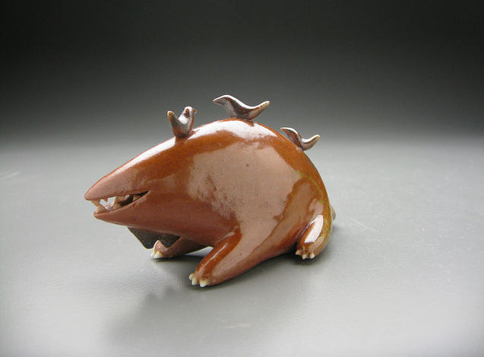 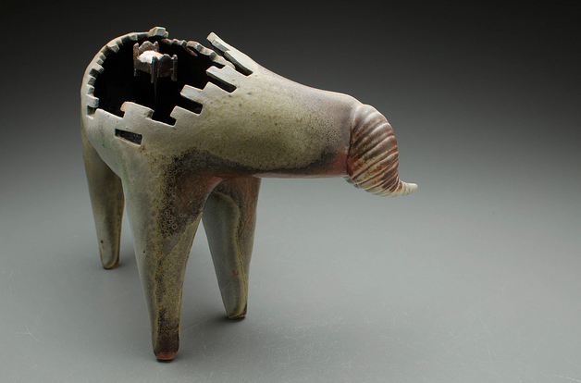 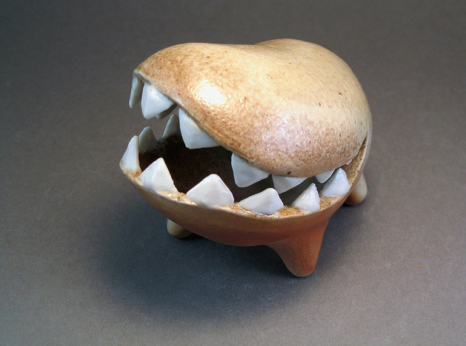

What would each of these creatures’ skills be? Can you tell from their physical appearance?

What is one word you could use to describe the overall work of Funderburgh?

**Ron Dee** grew up in Minnesota and has always known that art was his calling. His medium is ceramic. The work is odd, to say the least. Ron’s pieces reflect his unique sense of humor and his outlook on the world around him.

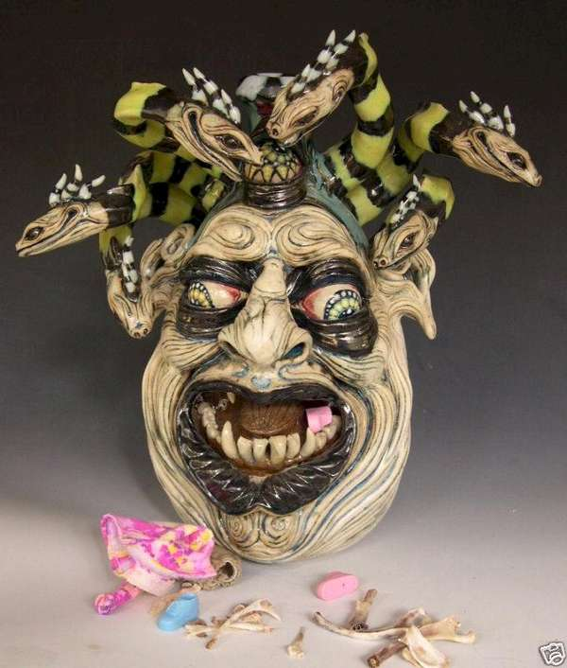 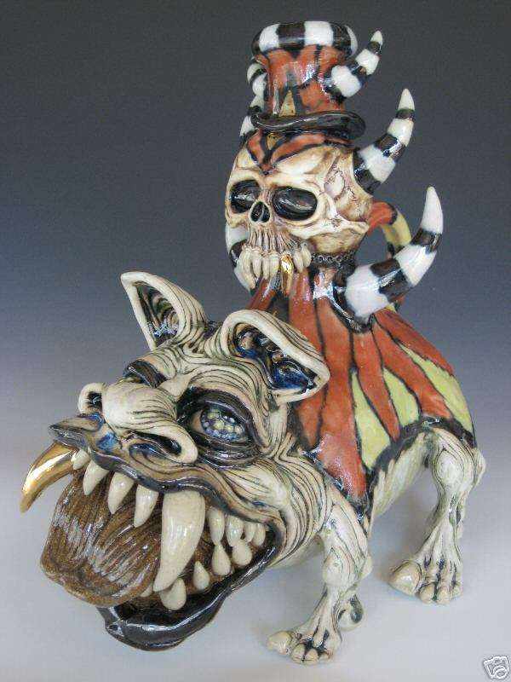 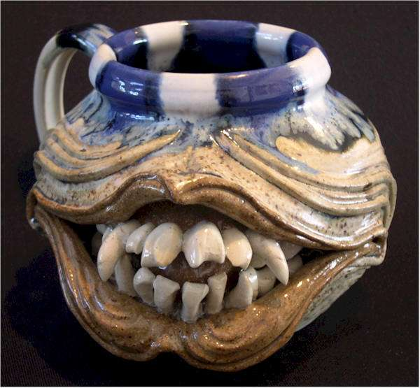

If these works were reflected Ron as a creature, what would they say about him?

Do you think that putting a gruesome smile on a useful item (i.e. cup, pitcher) changes the meaning of the faces rather than if they were purely sculptural?

**Debra Broz’s** work is most often about finding connections between fragments. Using found objects and images, she extracts meaning through anthropomorphism, context, language and memory. She is influenced by technologies like genetic mutation, symbiotic relationships, grafting and DNA manipulation her works also reflect her love for dark humor. She had training in china reconstruction and so she transforms these found objects to give them completely new meaning.

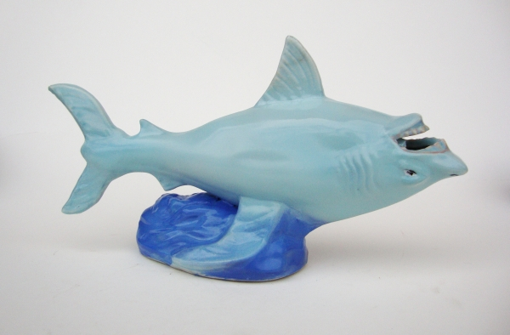 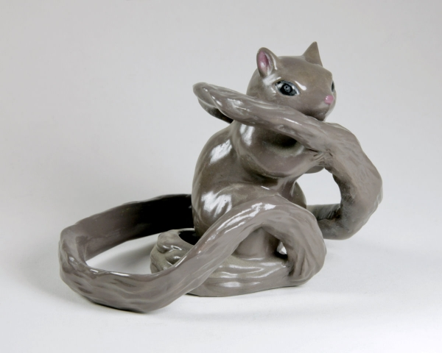 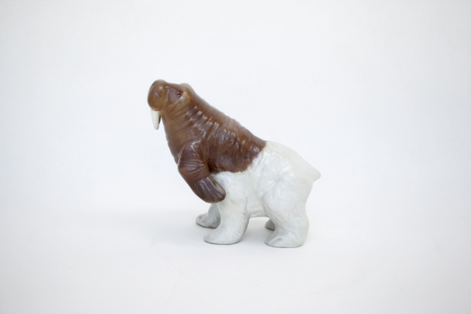

How does Debra use transformation in each of her works? Is it successful?

Is it important that these are found objects and not created by the artist?

9**.) Lesson Procedure**

**Day 1**

Introduction

“Hello artists! Today we are going to start a new project working with clay. In this lesson we are first going to discuss a few ceramic artists, then build a pitcher, finally you will transform this pitcher into a creature that represents yourself. This project will teach us most obviously how to build a pitcher, but also how to transform the pitcher into a super awesome creature version of you. Today, we are going to discuss our artists and then journal and sketch a bit about ideas. The project will be discussed more thoroughly as we get to each part, but as of now are there any questions?

Great! So now, let’s discuss the artists who are going to be influential to all of us. Remember that we are going to transform our pitchers from ordinary to extraordinary by making them into creatures? Well, each of our artists has different techniques and styles of creatures.” *Discuss artists above*

Work time

“After looking at the artists we can see how some of those creatures really had personalities that were visible. Your pitcher creatures can be as real or as imaginative as you would like. Right now, I would like each of your to get our your sketchbook and make a list of traits about yourself that could be translated into a creature. These could be both physical and emotional. My list may include: tall, listener, quiet, colorful, quirky, creative, etc. Lets talk about how to transform our traits into physical aspects of the creature. How could you show a trait of listening? (big ears, many ears) How could you show smart? (huge brain, exposed brain, glasses) Can someone volunteer a trait for us to brainstorm? Its okay if you can’t think of a direct way that the specific word could be translated to your creature. After you make your list, I want you to make a few sketches of ideas for the creature. Make sure to label the parts with words so you can come back to it later and understand the connection. So Julia, can you repeat what we are going to be doing right now? Right, we are going to build a traits list and then make a few labeled sketches. The artists’ examples are still on the board and I’m also setting out a few Dr. Seuss books and SciFi images at each of your tables so you can get creature building ideas. Are there any questions before I give you some time?”

**Day 2**

Introduction

“Hello students. Remember last time I introduced you to our new project. We learned about three artists who make creatures in very different styles and then did some sketches. Today, we are going to continue by having a demonstration on pitcher building and then you all will start on your own.”

Demonstration

“So first I am going to take my clay piece and roll it to about pinkie thickness with the roller. Next we are going to start cutting the slabs. This is where your first decision comes in. You have several options for shapes and sizes. You’ll want to cut two rectangle or square forms for the sides. I’m cutting mine here; I’ll hold them up for you so you can envision what these will be used for. Next comes the base. Usually this is some sort of oval shape so that the liquid will flow to one side, but if you are dead set in doing another shape, that is fine too. Just line up the bottom of your side slab with the clay so you can get the length of the base slab correct. Next, we are going to score and slip all of the sides for a firm attachment. After the initial pitcher shape is made, roll a few tiny coils so you can reinforce the seams to make them even stronger. Score and slip these, press, and smooth. Now that we have the completed body, lets move to the feature that makes this a pitcher: the spout. Cut a rectangle piece and fold it in half. Mark outside where it goes then cut along your marking. Score, slip and attach your spout. You’ll want to smooth out the edge of the spout for good pour-ability. These are the steps I want you to get through today. Leah, can you tell us the first step? Seth, what comes next? Very good, so roll out the clay then cut out the sides. Make the base and score and slip these together. What are we going to reinforce the edges with Katrina? Correct, coils. And after the coils, we cut and attach the spout. Are there any questions before we begin?”

Work time

Students will build their pitcher’s body. By the end of the day, this should be complete.

Closure

“For clean up today, make sure your name is on the bottom of your pitcher. Then place it on the rack under the plastic. Put your tools in the appropriate places and clean up your tables with sponges. Remember not to put clay down the school drains.”

**Day 3**

Introduction

“Last time all of you created the body of your pitchers. They all look relatively the same, except for size maybe. This should change by the end of today. Today you are going to start the transformation of your pitcher from ordinary to the creature based off of each of you. I want each of your sketchbooks next to you, so you can look back as a reference. Remember to keep yourself in mind with each step. By the end of this, the average Joe should hardly be able to tell that these are pitchers at all. One of the main things your can concentrate on today is the handle. You make a handle by rolling a thick coil and then shaping it to match your creature. Attach this with scoring and slipping. Are there any questions?”

Work time

Students will work on the transformation of their pitcher into a creature.

Closure

Same as Day 2

**Day 4**

Introduction

“Welcome back students. Today we are going to continue to work on our pitchers but first lets have a quick review of our artists.” *see artists above

Demonstration

Lets talk about how to make feet for your pitcher. These feet could be the literal feet of your creatures, or they could just be little squares added to raise your creature off the ground. You’ll want to have at least four for balance purposes. The feet could be different shapes horizontally, but make sure they are all the same height or your pitcher will be topsy turvy. You’ll attach these again, with scoring and slipping them really well. Are there any questions about feet or the project in general? Is anyone running into problems or figure our a cool method for manipulating the clay?”

Work time and Closure

Same as Day 2 & 3

**Day 5**

Introduction

“Last time we had a work day after viewing our three ceramic creature artists. Today will be the last day to build and transform because next time we come back to this, after they are dry, it will be glazing time. Who has a question about working today?

Work time

Students will complete their pitcher into creature transformation.

Closure

“For clean up today, make sure your name is on the bottom of your pitcher. Then place it on the rack under the plastic. Put your tools in the appropriate places and clean up your tables with sponges. Remember not to put clay down the school drains. Today we are going to leave our project uncovered until they are ready to be put into the kiln.”

**Day 6**

Introduction

“Our creature pitchers have been fired, so the next step is to glaze. The red table has the red and pink colors, the yellow table has yellow and orange, blue has all the blues, green has our two greens, and purple has purple as well as black. Remember that the color the glazes are now aren’t anything like what they will be like after they bake. So don’t worry if the color says blue but it looks like pink, it will turn out blue. I have the fired examples of the glazed colors next to the jars of glaze. So look at the example color- not the jar color. There are large brushes and small brushes so choose accordingly. I would start first by glazing the inside in a solid color, so then you can concentrate on the outside. You will need three coats. Pay attention to where you put the glazes, especially on the outside. Carefully carry your pitcher from the front table to the table that you want to glaze your inside. How many coats of glaze should we have everyone? Right, three coats. When you are done with in the inside, glaze the outside carefully, paying attention to your patterns. Try not to get glaze on the bottom of your mug because it will then stick to the shelf of the kiln. I need three good questions before we can begin.”

Work time

Students will glaze their clay projects

Clean up

Please make sure the lids are on the glaze containers. If someone from each table could go up and clean the brushes that would be great. Wipe down the tables with a sponge. Finished projects should go on the shelf and I will load them to the kiln from there. Great job today, I can’t wait to see how these turn out!

**12.) Assessment/Evaluation**

*see attached