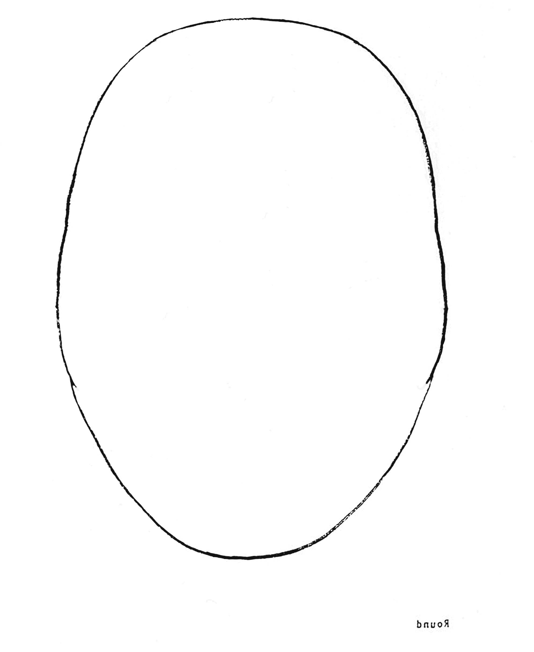

This worksheet is given to students as a tool to make their self-portrait.

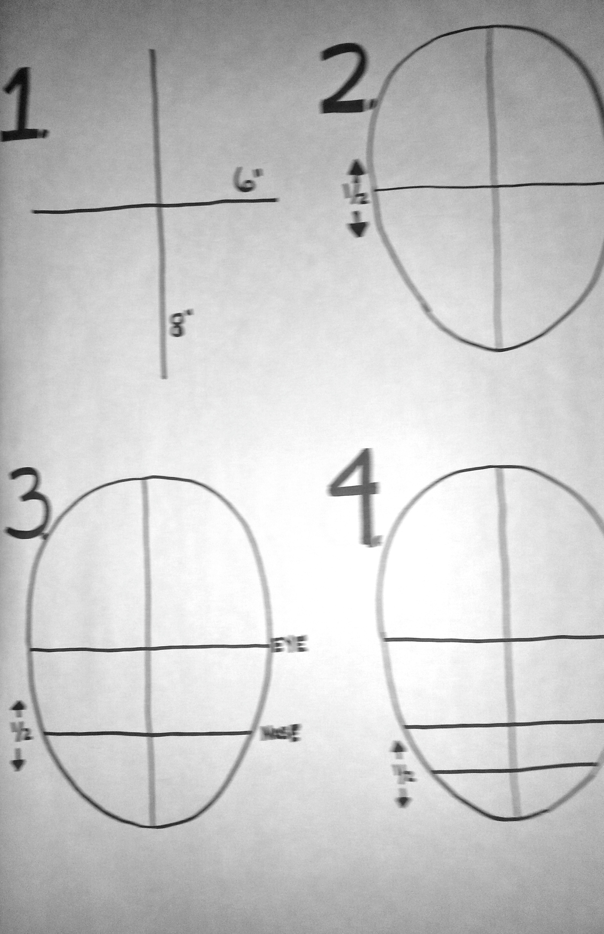 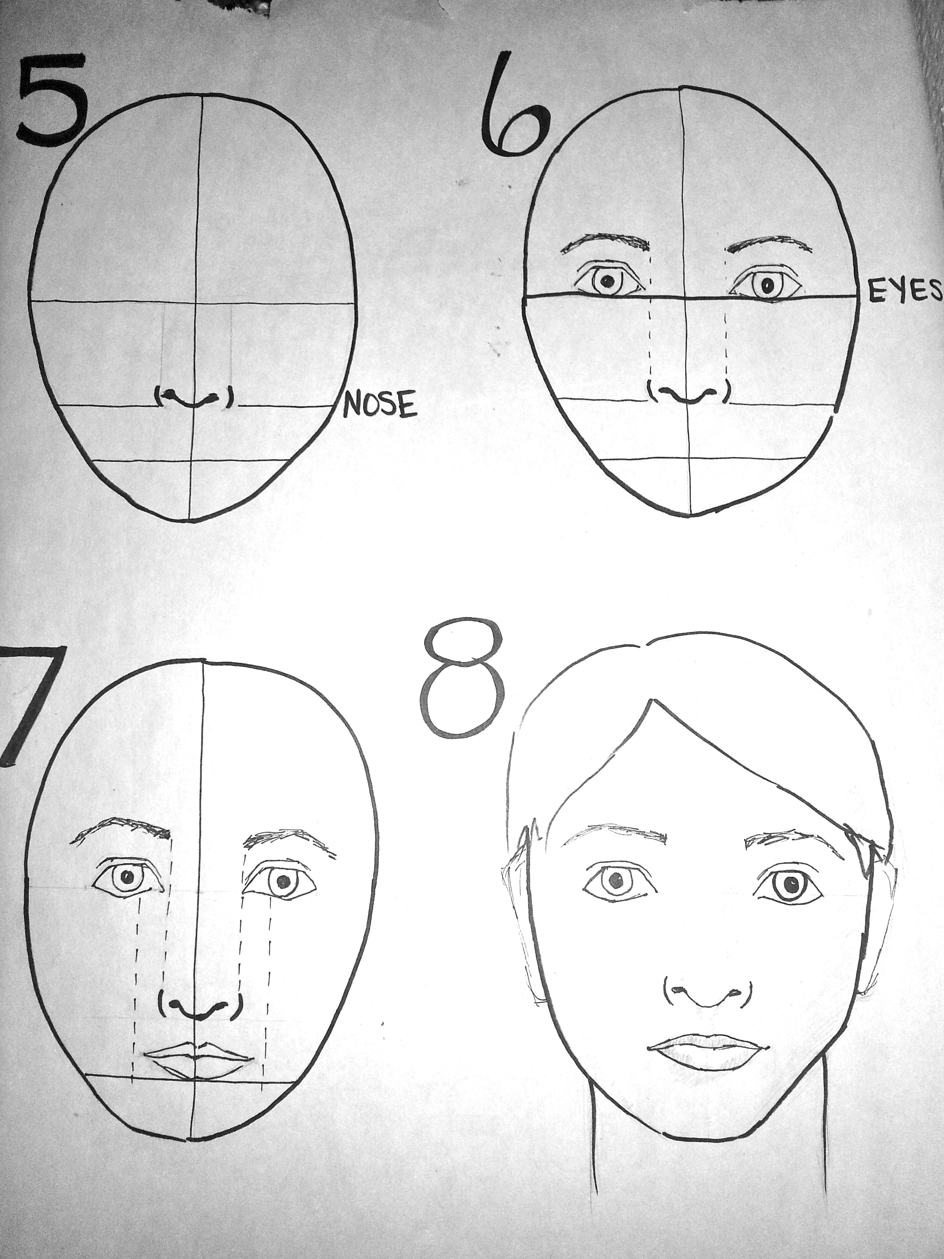

I created these posters of the “Eight Steps to Creating a Portrait” as an aid to students.