Learning Segment Overview  Color Theory  Lesson One:  Written Pre-Test  Color Theory Instruction  Lesson Two:  Color Charts Demonstration  Mix Color Charts  Lesson Three:  Artist Inspiration  Flora & Fauna Project Introduction  Lesson Four:  Materials Demonstration  Draw Flora and Fauna  Lesson Five:  Written Post-Test  Describing Artwork  Critique  Objectives  Students will demonstrate growth in understanding color theory with improved test scores from the pre-test to post-test.  S1  Students will create color-mixing charts showing knowledge in primary, secondary, analogous, monochromatic, and complementary color schemes.  S1, S2  Students will create two pieces of artwork, one flora and one fauna, that each shows knowledge in one of the three ideas: analogous, monochromatic, or complementary modeling the style of Liz Laribee and historic illustrators.  S1, S2, S3, S6  Students will thoughtfully answer the descriptive questions about their finished artwork.  S6, S7, S11  Student will come to class on time and work efficiently.  Productivity and Accountability  Procedure  Day One  Written Pre-Test  *See attached Test (A)  Students will demonstrate growth in understanding color theory with improved test scores from the pre-test and post-test.  The written pre-test is given to students to gather data about their knowledge of color theory. This tests their basic color theory vocabulary and color mixing knowledge. Students are told to answer honestly so that I know their background knowledge. It is not graded for anything other than participation points. Immediately after taking the test, go over correct answers with students so they can learn from the experience.  Color Theory Introduction  *See attached Flip chart (B)  “Color Theory is important because color effects us daily, whether we are aware of it or not. In art, it is important that we understand how color works. Color is important in the choices that we make when creating artwork." Show art history images for each of the five vocabulary words on flip chart. After reviewing the vocabulary words, show students slide of color theory in “real life”. Then have students turn their pre-test over, and go over the art history images. This time, have them identify under which category they fall: Primary, Secondary, Complementary, Analogous, or Monochromatic.  Questions on Color Theory:  - What are the Primary Colors?  - What are the Secondary Colors?  - How do you make a Secondary Color?  - What are Analogous Colors? (Colors next to each other)  - What are Complementary Colors? (Think of Christmas, Panthers, and Bears colors)  - What is a Monochromatic color scheme? (Mono means one)  Day Two  Color Charts Demonstration  “Now we are going to take what we learned yesterday and put it into practice. Let’s review our five main vocabulary words: Primary, Secondary, Analogous, Monochromatic, and Complementary. How can we remember what the complementary pairs are?” Use bulletin board as a tool for instruction (C)  Demonstrate:  - Making 4 color charts with 6 one inch boxes with a ruler  - Labeling the last box on each chart with the name of a color scheme  - Mixing paint in the paint tray  - Washing brushes with soap in the sink  Work time: Students start to create their color charts by first measuring one-inch boxes for their charts. If there is extra time, they may start by painting the Primary to Secondary color chart.  Day Three – Day Four  Student Work Time: Mix Color Charts  Students will create four color-mixing charts showing knowledge in primary, secondary, analogous, monochromatic, and complementary color schemes.  During student work time, check for understanding and circulate room for individualized instruction.  Day Five  Artist Inspiration  “Today we are starting our color theory project. First, I’m going to talk about the project inspiration, then give an overview of the project, then we’ll finish up by doing a demonstration on how to use our materials and what to make.  Liz Laribee is a contemporary artist. Who knows what that means? She typically draws on things that most people throw away – like napkins and cardboard. After looking at some of her cardboard pieces, I decided to try one of my own. The process of ripping away the cardboard was so fun I decided to try and make it into a lesson for you all.  What do you guys think about stealing ideas from other artists? Is it good or bad? Talk at you tables for a minute and decide then give me a thumbs up or thumbs down. I just want to let you guys know that it’s okay to steal from other artists. Just make sure you steal properly: by crediting the artist and studying a lot of their work, rather than one piece. If you find something that you love to look at, chances are you’ll love to make it too. Eventually, you can make several versions of your original inspiration and it’ll gradually change each time to fit your own style.”  Liz Laribee’s Website: Questions to Consider:  - What materials does Liz Laribee use?  - Why does she choose these materials?  - Describe the sizes of her lines  - How does she make her works of art have contrast or pop out?  - Where does she place her figures? (Notice there are no floating heads)  - She rips away the cardboard in different ways, which do you like the best and why?  - Which is your favorite?  - Look at the elements and principles in design, describe these  Flora & Fauna Project Introduction  *See Project Flip Chart (D)  *See Student Handout (E): Give this to students at the beginning of class to take notes on  Anticipatory Set  Throughout history, artists have been used to document plant and animal life forms around the world. When European explorers went to the New World, artists were hired as part of the crew to illustrate pictures of new plant and animal species. These drawings were brought to Europe for people to learn from.  Recently, there was a giant new island found on Earth named Colourloo. Artists are needed to document the life forms on this island. It is the students’ job to document these new life forms.  Flora and Fauna Video: Questions to Consider:  - What was the purpose of creating these plant and animal images?  - How did they create them?  - How accurate are they?  - Why were artists needed to go on these voyages? (What had not been invented yet?)  Review the color schemes / Demonstration  - How to use materials: Pen and chalk pastel  - Techniques of drawing plants and animals  Exit Ticket  - What is flora and fauna?  - Who is Liz Laribee and what materials does she use?  - Who is Sydney Parkinson and what does he illustrate?  Day Six  Artist Inspiration Kinetic Review  “The plan for today is to first do a quick review activity of our discussion from yesterday. Then I’ll demonstrate our process for making the flora and fauna. Finally you all will get started making your own flora or fauna today.  I have a review activity for you all. I have seven true false questions for you about what we learned yesterday. If you think the answer is true, you stand. If you think the answer is false, stay in your seat. Either way, I may call on you for why you chose the answer. So for example, the first question is ‘The primary colors are red, yellow, and blue.’ (So you all will stand up.)”  - (F) Liz Laribee likes to paint and use a lot of color.  - (T) Artists were hired to document the plants and animals because cameras weren’t invented yet.  - (T) Liz Laribee is a contemporary artist who works on cardboard and napkins.  - (F) Flora means animal in Latin.  - (T) Sydney Parkinson is a historical illustrator who went on voyages to draw flora and fauna.  - (F) Liz Laribee’s main subject matter is trees.  - (T) Fauna means animal in Latin.  Chalk Pastel / Xacto Knife Demonstration  Demonstrate the following techniques:  - Working dark to light  - Blending  - Showing line variation  - Detail work  - Safety with knives, how to hold  Work time: Students will start off the project by looking in books and magazines for an image of both a plant and animal that they can use as reference to draw. They will start by sketching out that image on the cardboard.  Day Seven – Day Nine  Student Work Time: Flora & Fauna  Students will create two pieces of artwork, one flora and one fauna, that each shows knowledge in one of the three ideas: analogous, monochromatic, or complementary modeling the style of Liz Laribee and historic illustrators.  Day Ten  Post-Test Review  At the beginning of class, students will play a review game for the color theory post-test. This is a group activity that students will do at their tables. Each table will be given a laminated color chart. Color clues will be read off, and the first student to point to that color will receive a point.  - The three primary colors are yellow, red and ______________.  - The three secondary colors are green, purple, and ______________.  - The complement of purple is ___________________.  - The complement of green is ___________________.  - The complement of orange is _______________.  - Blue and yellow make __________________.  - Red and Yellow make __________________.  - Blue and Red make ___________________.  - Pink is a tint of __________________.  - Point to an analogous color of both green and orange.  - Point to the tertiary color that yellow and orange make.  - Point to the tertiary color that red and violet make.  Post- Test  Students will retake the same test that they did entering the project in order to collect data. This test will be counted to point value.  Description Questions / Critique  Students will thoughtfully answer the critique questions about their finished artwork.  First, students will answer the description questions about their work and a peer’s artwork. Next students will come together for a large group critique. We will put all the images on the table and describe them as though we were living in the 1700’s and looking at the flora and fauna. Once one student’s work has been picked to talk about, they pick the next artwork to keep the discussion rolling. See PowerPoint (F)  Student Learning  Differentiation Plan  Objectives  Students will demonstrate growth in understanding color theory with improved test scores from the pre-test to post-test.  Students will create color-mixing charts showing knowledge in primary, secondary, analogous, monochromatic, and complementary color schemes.  Students will create two pieces of artwork, one flora and one fauna, that each shows knowledge in one of the three ideas: analogous, monochromatic, or complementary modeling the style of Liz Laribee and historic illustrators.  Students will thoughtfully answer the critique questions about their finished artwork.  Students will come to class on time and work efficiently.  Student Needing Accommodation Project Goal Instruction Time Material Theme Assessment Description of plan to meet needs  ELL Material Have visuals of instructions and steps available to print off.  At-Risk Instruction Time Give students individual instruction and attention to keep them engaged during class. Able to turn in assignment after the due date without penalty to grade.  Gifted Project Goal Option for additional design on color charts. Once done with the Flora and Fauna, create a project with the color scheme that has not been used  Attitude Theme Instruction Students will be given choices throughout the unit. For example, they will be able to choose their subject matter in the Flora and Fauna project. Reinforce desired behavior  Assessment  Before the Learning Segment  Gathering information about student knowledge:  Day One: We will be spending time gathering information about student knowledge. There is a pre-test over color theory knowledge and the vocabulary associated with color theory. These scores will not be counted for point value, but rather for participation points. Students will be asked to answer honestly in order to gather information about the prior knowledge.  During the Learning Segment  Informal Formative Assessment  Day One: At the end of Day One. Students will have taken the pre-test about color theory. Then they will have reviewed the basics of color theory with a FlipChart: the vocabulary words will each have an artwork for the students to associate with the word. At the end of Day One, there will be a FlipChart showing the associated artwork without the vocabulary words. Students will label the each artwork with the vocabulary word that describes it. They will turn this in so I can evaluate both the pre-test taken before instruction and the vocabulary words studied after instruction.  Day Two: At the beginning of Day Two, we will review the vocabulary concepts that were taught on Day One.  Day Three – Day Four, Days Six – Day Nine: While students are working on their color charts, I will be circulating the room giving individualized instruction. This will show me how well students received and processed the color theory information.  Day Five: Students will turn in an Exit Ticket at the end of the day asking about the basis of the project for that day. This will all be used as closure for the day.  Day Six: Artist Inspiration Kinetic Review Activity. Students will sit or stand depending if they believe the answer to be true or false. This will give me non-verbal feedback from the entire class about the information they retained about Liz Laribee and historic illustration.  Formal Formative Assessment:  Day Five: Students will turn in their color charts. This will be graded and assessed for understanding of color theory. Each of the four assigned color charts will be assessed separately. I will be able to gauge how well students understood the color schemes by looking at how well students did collectively on each of the four charts. |  | Ms. Vander Wilt  Fundamentals of Art  Fall 2014  Big Idea  Color Theory  Goal  Students will understand color theory as a way to create artwork throughout the semester and to better recognize design choices made in the world around them.  Arizona Art Standards:  Creating-Conceiving and developing new artistic ideas and work  1.Generate and conceptualize artistic ideas and work  2. Organize and develop artistic ideas and work  3. Refine and complete artistic work  Presenting-Realizing artistic ideas and work through interpretation and presentation  4. Analyze, interpret, and select artistic work for presentation  5. Develop and refine artistic work for presentation  6. Convey meaning through the presentation of artistic work  Responding-Understanding and evaluating how the arts convey meaning  7. Perceive and analyze artistic work  8. Interpret intent and meaning in artistic work  9. Apply criteria to evaluate artistic work  Connecting-Relating artistic ideas and work with personal meaning and external context  10. Synthesize and relate knowledge and personal experiences to make art  11. Relate artistic ideas and works with societal, cultural and historical context to deepen understanding  Purpose Statement  We think about color daily without even knowing it. Color theory is part of our fashion, home design, logos, children’s toy, food labels and more. In art, it is important to know how to mix different colors and how different colors work when they are side by side. As you are putting color on your flora and fauna, notice how those colors work together.  Materials  - Paper  - Ruler  - Scissors  - Red, Yellow, Blue, White & Black Tempura Paint  - Paintbrushes  - Paint tray  - Sharpies  - X acto Knife  - Chalk Pastel  - Cardboard  Resources  - Written Test  - Assignment Handout  - Color Theory Flipchart  - Project Introduction PowerPoint  - Natural History YouTube video https://www.youtube.com/watch?v=HeaNgNfeXBc  Color Schemes for Charts  Primary to Secondary  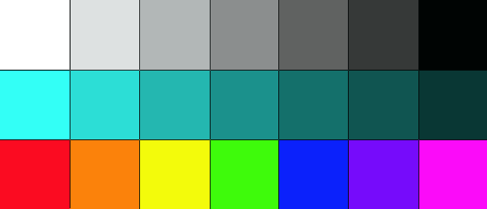  Monochromatic    Analogous    Complementary  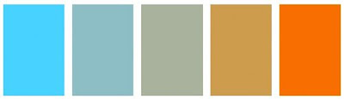  Vocabulary  Primary: Red, Yellow, Blue, cannot be mixed with other colors  Secondary: Orange, Green, Purple, created by mixing two primary colors together  Monochromatic: One color, with black and white added  Analogous: Colors next to each other on the color wheel  Complementary: Two colors opposite each other on the color wheel  Tint: Hue with white added  Shade: Hue with black added  Value: Lightness or Darkness  Neutral: Two complements mixed  Artist / Imagery  Liz Laribee: Contemporary  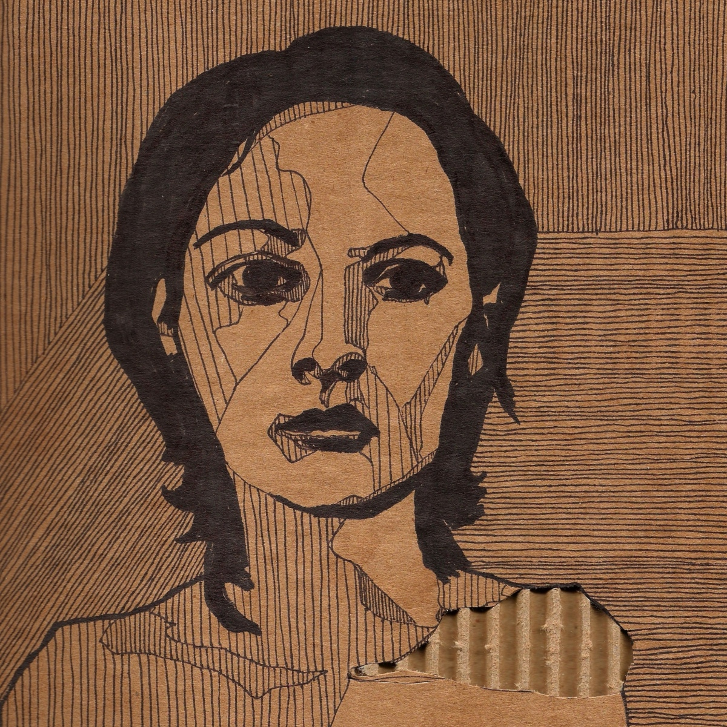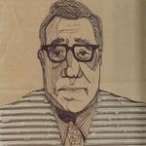  Artist Statement: “I like to choose materials at odds with each other: For a drawing surface, I work typically with cardboard and napkins, both identified by a temporal, tossed away quality. Most of the time, these things are on their way to the trash. For a drawing tool, I am partial to Sharpie, an indelible and unforgiving medium; each line I mark on the paper immovable and un-erasable. It's an attempt to capture snapshots of characters, who have lasted, on a material that doesn't stand a chance.”  http://www.lizlaribee.com  Sydney Parkinson: Historical  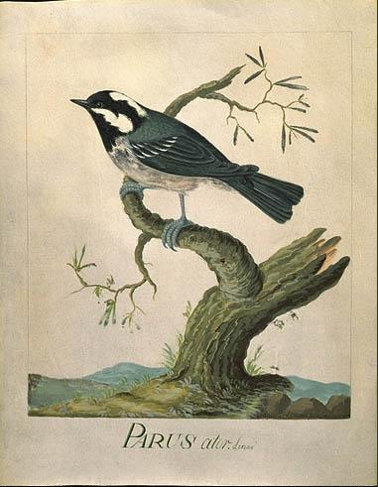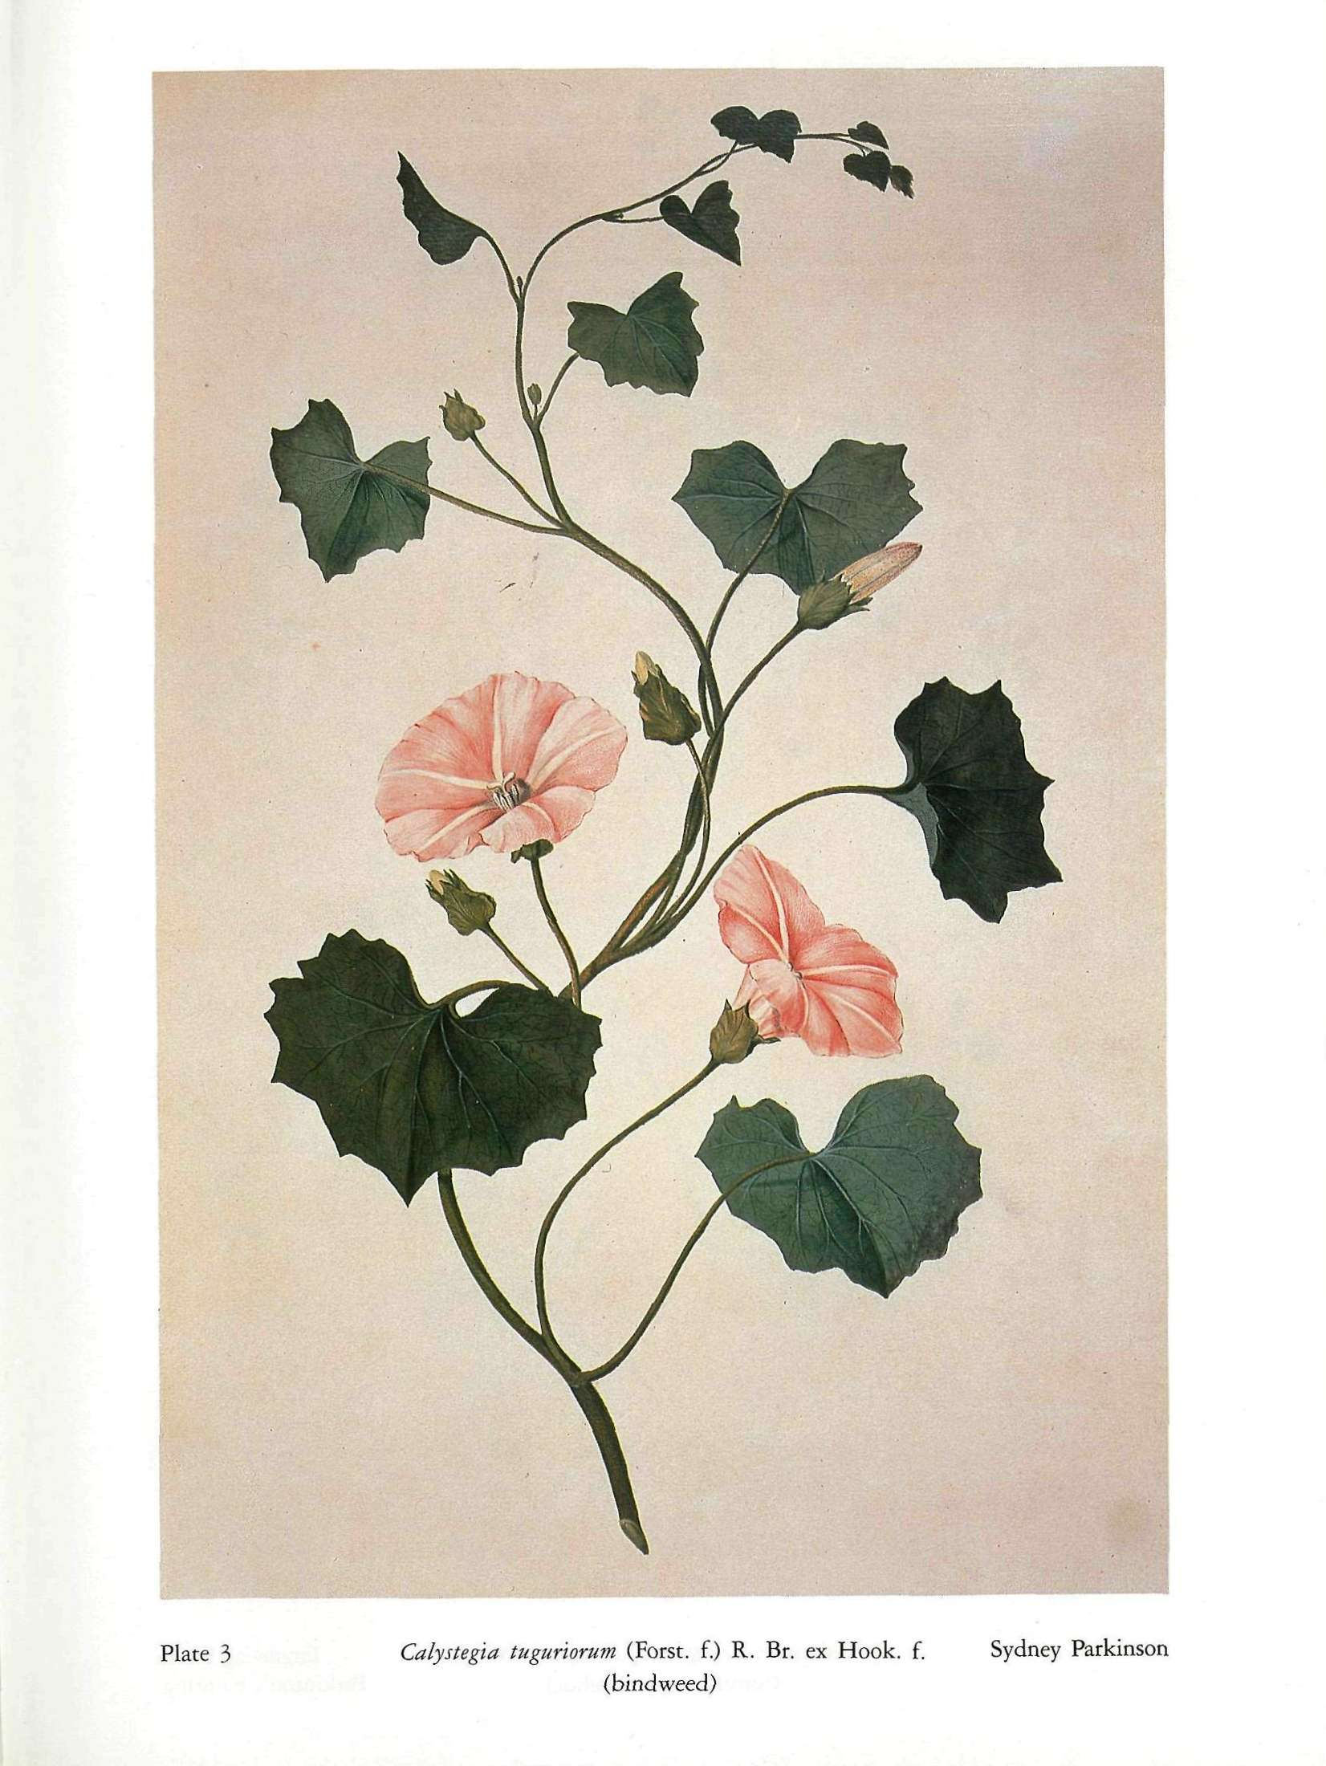  Biography: Sydney Parkinson was a Scottish Quaker from the 1700’s. He was botanical illustrator and natural history artist. Parkinson was employed by Joseph Banks to travel with him on James Cook’s first voyage to the Pacific in 1768. Parkinson made nearly 1000 drawing of plants and animals.  http://www.nhm.ac.uk/nature-online/art-nature-imaging/collections/first-fleet/flora-fauna/  Procedure for Flora / Fauna  - Outline plant/animal on cardboard with pen  - Pick color scheme  - Use chalk pastels to fill in plant / animal  - Use X acto knife to rip away cardboard  - Label color scheme on the back of cardboard  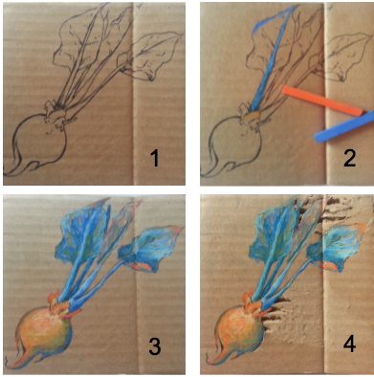  Descriptive Question Example  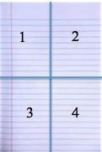  Descriptive Questions for Flora and Fauna project:  - Describe the color scheme that you used on the flora.  - Describe the color scheme that you used on the fauna.  - Explain the most successful part of your cardboard pieces.  - If you were to make a third cardboard piece, describe what it would look like. How would it change?  Closure  “Now that we are done with the Post-Test, we have all graduated from our study of color theory. Even though we are done with color theory, that doesn’t mean you should just throw this information out of your brain. Color theory will apply to every project that we work on from here on out, and I expect that you will use all of this information to make your projects exceptional. What are some of the decisions we make that are influenced by color theory? (fashion, home design, logos, food)  Classroom Management  Catering to the Affective Domain  Students will know the plan everyday as we discuss both short term and long term goals for the unit. Knowing what is expected everyday will make students feel comfortable in the room. Feeling comfortable in the environment is the first step to being creative in the art room. We will gather at the beginning of each day to set out the expectations of that day, either doing a demonstration or a review of color theory.  Instructional Design  Making the instruction realistic, relevant, and stimulating are preventative steps for students who may become a disruption in class. I will involve students in the planning of their projects.  Strategic Classroom Arrangement  Students are expected to sit down in their assigned seat throughout class. This prevents disruption by creating a daily routine. This also can be used to accommodate individual learning needs (i.e. hearing impaired, ADD). Teacher will circulate classroom as a first step to acknowledging unwanted behavior without disrupting the continuity of the classroom.  After the Learning Segment  Formative  Day Nine: We will review for the test, which is on the following day. This information will be considered as to whether students need more information before taking the post-test.  Summative  Day Ten: Post Test. This test will be assessed for point value. This test is the most objective data to be gathered about student knowledge during this learning segment.  Day Ten: Critique. Students will answer questions about their Flora and Fauna projects. They will describe their process, successes, and what they would change.  Day Ten: Flora and Fauna Project. This is their final art project for the color theory unit. This will be evaluated with a rubric.

